2.1.13 Customer Ship-to Maintenance

We enter new Ship to Party addresses via this function.

Customer: means Sold to Party customer number (under this number will be new delivery address added)
Customer Ship-To: just press enter to get it
+ YES, we wish to add
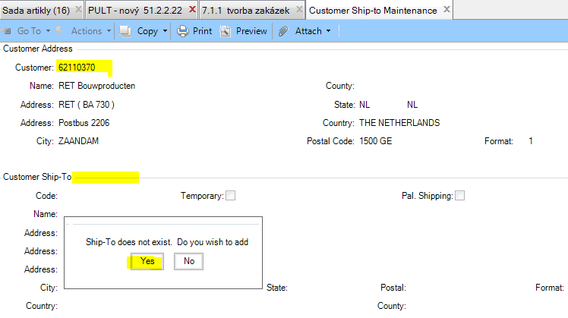

Code: now we have here new Ship to Party customer number starting with S.
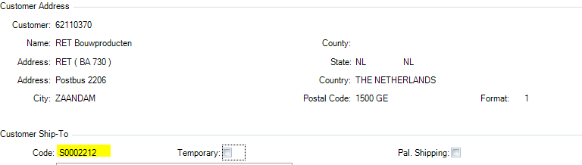

Let´s fill all below fields.
Note that there is just limited space for characters (digits, letters) in each field.
If so, just write it into below field. It is allowed to split e.g. addresses, e-mail address.

Name: fill customer´s name (here has to be splitted into 2 lines – name is too long)
Address: street
City: town
State: 2x NL (as you can see below)
Postal: postal code
Attention: contact person
2: e-mail address
Telephone: phone number
Sort Name: searching term (according this data you will search Ship to Party)
+ Next
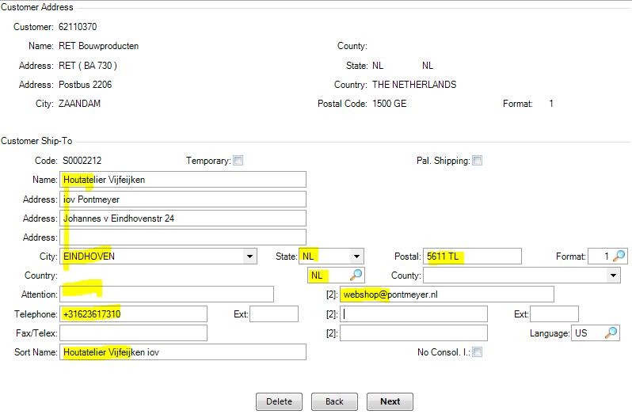

All below information come from 2.1.1 Customer Maintenance from Sold to Party.
Id Nbr: this field has to be empty
Vat Number: this field has to be empty
+ Next and that´s it
